**CCGC 5004 Database Systems**

**Lab Exercise 8**

Open an existing EER diagram in MySQL Workbench

Click the Home button in MySQL Workbench. You do not need to click on your connection. To generate a schema you do not need to be connected to your schema. Click on the area identified below.

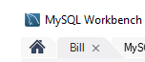

It is located in the top left corner of MySQL Workbench

This will bring you back to the Home screen. Notice the darker strip on the left side of the screen

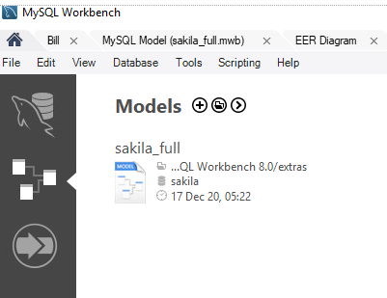

The centre icon will open the MySQL Workbench for database design. There is a sample schema that has been created. You can click on the entry and open it.

Beside Models click the circled plus sign

This will open the following screen:

Double-Click the Add Diagram icon at the top to begin a new diagram. You should see this:

If you do not see the grid, you will need to create a new VM for this exercise. This is an issue that has occurred every semester. The tech people at MySQL have not been able to provide me a solution. You do not need a connection to the database since you are going to generate a script that would be run against the database to create your schema.

Before you begin to create your schema there is a sample schema you can view.

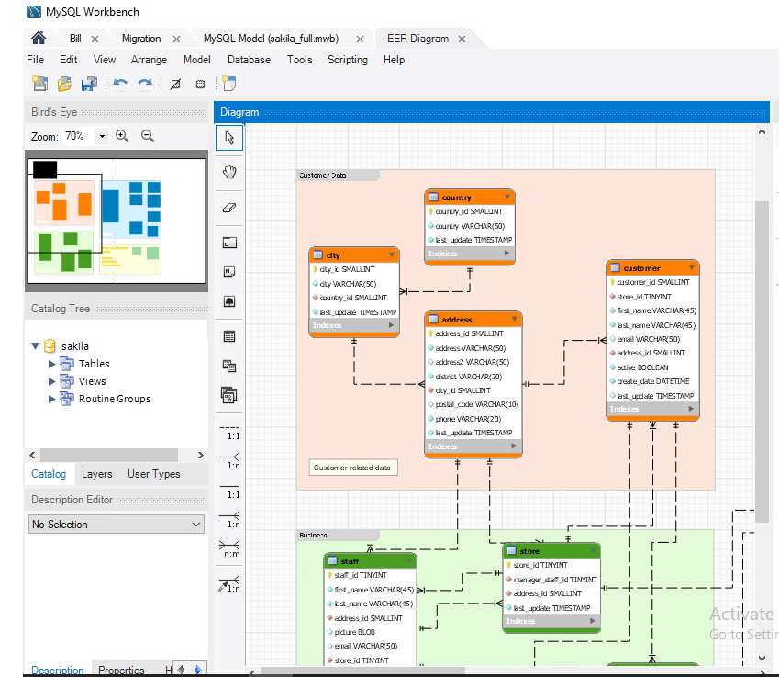

You can expand Tables on the left side. You can see the columns for each table, datatypes, constraints. There are Tabs below in the Catalog tree where you can view the Catalog, Layers and User Types.

Follow the posted document to create your EER for the given scenarios below. Thank you to Sally Kyvernitis for posting this reference to create an EER with MySQL Workbench.

**Lab Questions**

**We will walk through number 1. You are on your own for numbers 2 and 3.**

1. Use MySQL Workbench to create an EER diagram for a database that stores information about products.

Each Product must have a product name, description, and price.

Each product must belong to one category.

Each category must have a category name and description.

Each category can include multiple products.

1. Use MySQL Workbench to create an EER diagram for a database that stores information about customers.

Each customer must have an email address, first name, and a last name.

Each customer can have two or more addresses.

Each customer can have a default billing address and a default shipping address.

Each customer must have a street address, city, state, postal code, and a country.

Each country name should be stored in one place only. In other words, you should not store the name of the country, which be many characters, in the address.

1. Use MySQL Workbench to create an EER diagram for a database that tracks the memberships for an association and for the groups in the association.

Each member must have an email address, first name, and last name.

Each member can belong to any number of groups.

Each group must have a name.

Each group can have any number of members.

1. For the following exercise you have a many-to-many relationship that exists between STUDENT and CLASS.

The STUDENT entity is defined so each student may take many COURSES and each CLASS can be taken by many STUDENTS.

The STUDENT entity contains a STU_NUM, a STU_LNAME and a STU_FNAME. The CLASS entity contains a CLASS_CODE, CLASS_SECTION, CRS_CODE, CLASS_TIME, ROOM_CODE, and a PROF_NUM.

Create the ERD to show the initial relationship that exists between STUDENT and CLASS.

Modify this initial ERD so it now has the many-to-many relationship resolved.

This will involve two diagrams. A before and an after diagram.

Submission for Lab:

Screen capture of the diagrams, there will be 5 of them. I each for questions 1 to 3 and then 2 for Question 4

SQL Script screen capture, just show a portion of the script, do not need the entire script.